HyeSung Hwang, Piano recital
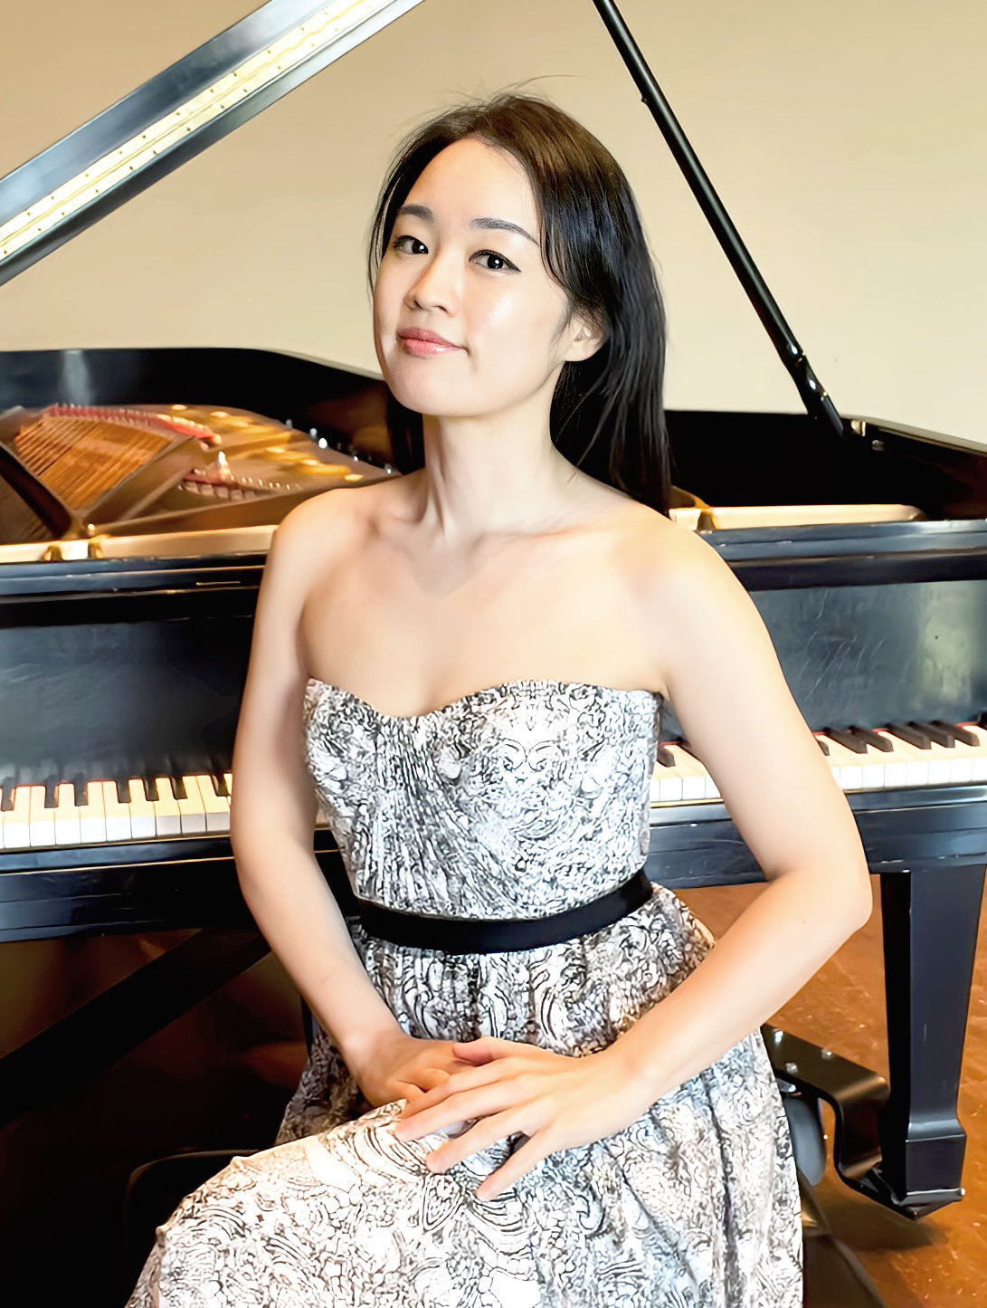

St. Paul’s Lutheran Church
25 West Springettsbury Ave.
York, Pennsylvania

Sunday, November 23, 2025
4:00 PM
Internationally celebrated pianist Dr. HyeSung Hwang is known for the warmth, power, and elegance that she brings to her interpretations of a wide range of repertoire. Born in Seoul, South Korea, Dr. Hwang has been awarded top prizes in numerous piano competitions including the Seoul Philharmonic Concerto Competition, the Young Artists Piano Competition in Seoul, the Samick Piano Competition, the Em-Youn Music Competition, and the Puigcerda International Piano Competition in Spain. Her achievements were recognized by the Maryland State Arts Council in 2011 with an Individual Artist Award. Dr. Hwang has performed actively as a soloist throughout Korea, Japan, Italy, Spain, France, and the United States. She has participated in numerous international music festivals including the Em-Youn Music Festival in South Korea, the Tivoli International Music Festival in Italy, and the Festival Music Alp in Courchevel, France. As a dedicated educator and mentor, Dr. Hwang has been teaching since 2001 and has produced many competition winners. She is currently teaching at York College of Pennsylvania in both the college and preparatory divisions. Dr. Hwang holds a Bachelor of Music degree from Seoul National University in South Korea where she studied with Dr. Ic-Joo Moon and Dr. Dae-Uk Lee. She also received a Master of Music, Graduate Performance Diploma, as well as the Doctor of Musical Arts from the Peabody Institute of the Johns Hopkins University under the tutelage of Dr. Alexander Shtarkman.

