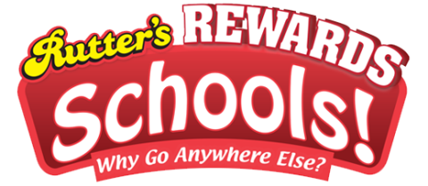
Dear Members of St. Paul’s and Preschool Parents,
We are excited to announce that we are participating in the new Rutter’s Rewards Schools program!

We are looking to raise money for updated/new toys. You can help us get this much-needed funding by signing up today!

It’s easy:
- Log in to ruttersrewards.com or the Rutter’s mobile app.
- Click Rutter’s Rewards Schools, then Select St. Paul’s Lutheran Preschool from the list and click the Support selected charity button.
- Each time you shop at Rutter’s using your Rutter’s Rewards card or Phone Number ID and passcode, it will help us reach our fundraising goal.

Shop at any Rutter’s location; purchase fuel, candy, snacks, coffee, or fresh made food and use your Rutter’s Rewards card or Phone Number ID and passcode. Every dollar you spend helps us raise money!

Accumulated Purchases | Organization  Receives
$1,000 | $50
$2,000 | $100
$3,000 | $150
$4,000 | $200
$5,000 | $250

Not a Rutter’s Rewards Member or VIP?
Pick up a card at any Rutter’s store.
Go to ruttersrewards.com and register today!

Please encourage your friends, family, coworkers and neighbors to register their Rutter’s Rewards card and choose St. Paul’s Lutheran Preschool from the list!

Thank you for your continued support. We hope you will consider participating in this program.

