Wise Men
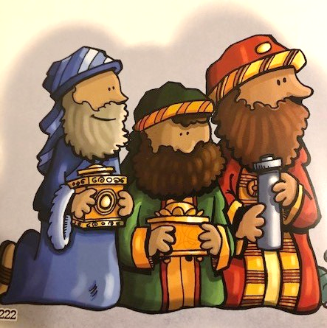
The Church celebrates the coming of the Wisemen on January 6, and we call the day Epiphany. It also marks the day of Jesus coming to the Gentiles. (Those of us who are not Jewish.) Some people wait until January 6 to move their wisemen figures to the creche. This is a great lesson to plan special activities for your family to mark the conclusion of the Christmas Season, The 12 Days of Christmas.
Did you know that the wisemen probably didn’t arrive until 2 years later? That’s what some biblical scholars say. We include them in our creches/manger scenes, but they weren’t actually there at the stable. Some people wait until January 6
The Spark Family Magazine that came in December has six pages of ideas.
Read and discuss the story together in Matthew 2:1-12. It is also found in the Spark Story Bible on page 218 and the Paraclete Bible for Kids on page 203. How did the wisemen know where to go? How do we find our way today?
Project: Find a program or organization that supports families with babies such as The Women’s Care Center at 40 S. Richland Ave. York, Pennsylvania | Women's Care Center Find out what they need. Shop together online and deliver gifts to the center. (Be sure to call and check on Covid restrictions)
Pray: Thank you God for sending the wonderful gift of your Son, to us and to all the world. Help us to tell others about this gift. Amen.

